Bash scripting-
1:input and output scripting.
#!/bin/bash
Echo hello everyone
Echo
Read name
Echo good morning $name
Echo
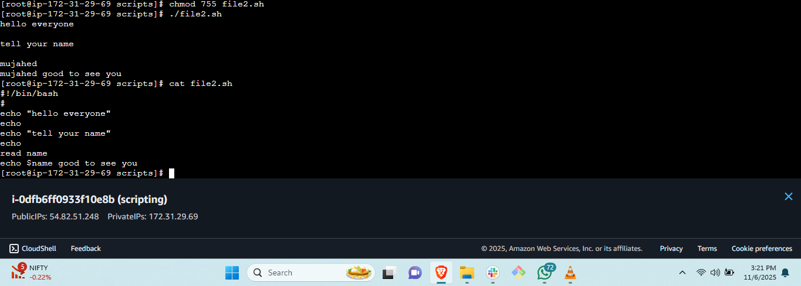
2: administration task: sanity test: daily execution commands.
#!/bin/bash
echo sanity test.
p=pwd
w=whoami
c=cal 2023
echo run variables…..
$p
$w

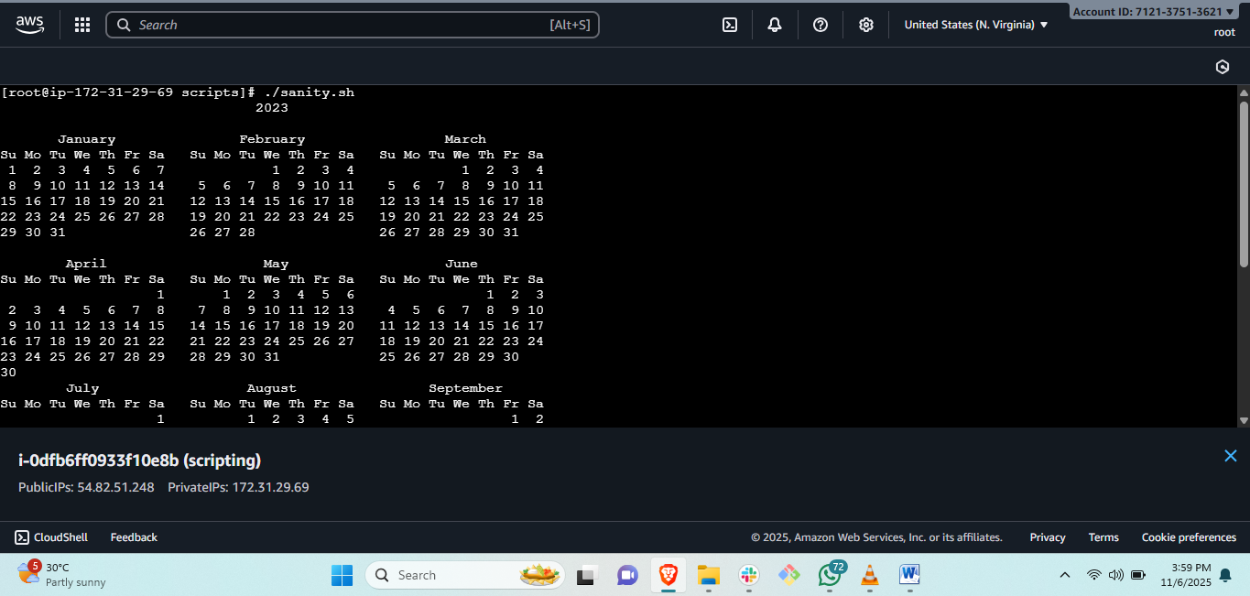

Sample input/output script:
#!/bin/bash
Echo hello my name is mujahed
Echo
Echo whats your name?
Read name
Echo
Echo good to see you $name
Echo where are you from
Echo
Read $place
Echo
Echo $place is far away from here how will you manage.

